

***DIGITAL ASSIGNMENT 1***

**(VTOP Submission due date: 08-JUL-2023)**

**Subject: ITA6003 Internet and Web Programming**

**Name:** Manvendra Gosain

**Registration Number:** 22MCA0321

**Total Marks : 10**

1. Create a webpage that displays your Bio data like below sample. Use your personal details under each section.

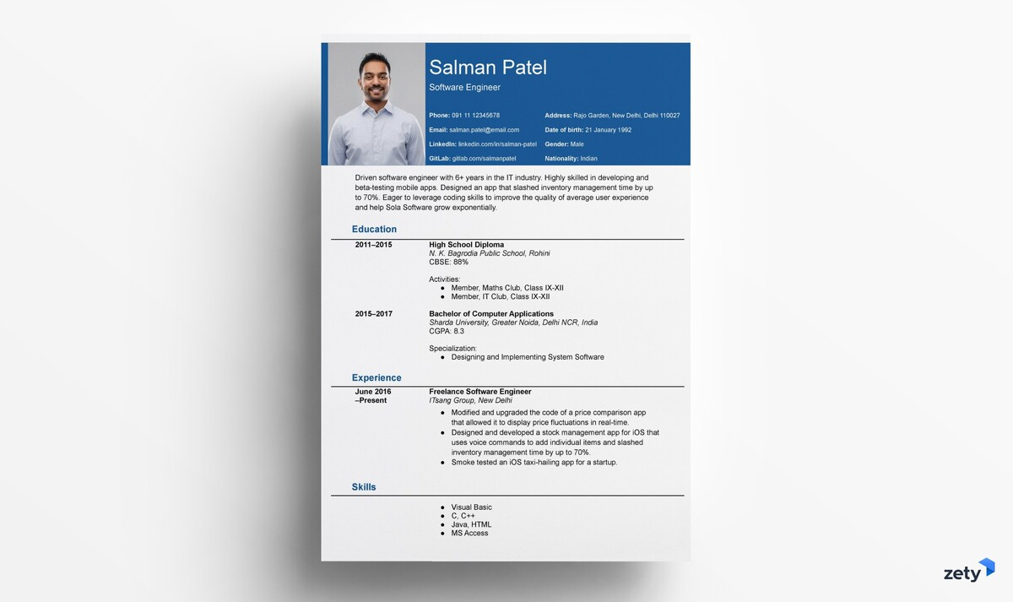

**index.html:**

<!DOCTYPE html>

<html lang="en">

  <head>

    <meta charset="UTF-8" />

    <meta name="viewport" content="width=device-width, initial-scale=1.0" />

    <title>Resume</title>

    <link rel="stylesheet" href="style.css" />

  </head>

  <body>

    <div class="container">

      <nav>

        <img src="./Manvendra Photo.jpg" alt="Profile Picture" />

        <div id="containerDetails">

          <div>

            <p id="name">Manav Gosain</p>

            <hr />

            <p id="domain">Software Engineer</p>

          </div>

          <div id="personalDetails">

            <div class="details">

              <p><b>Phone:</b> 1234567890</p>

              <p><b>Email:</b> k.gosain7140@gmail.com</p>

              <p>

                <a href="https://www.linkedin.com/in/mangosain/">

                  <b>LinkedIn:</b> linkedin.com/in/mangosain/

                </a>

              </p>

              <p><b>Github:</b> https://github.com/mangosain</p>

            </div>

            <div class="details">

              <p><b>Address:</b> VIT, Vellore Campus</p>

              <p><b>Date Of Birth:</b> 15th June 2000</p>

              <p><b>Gender:</b> Male</p>

              <p><b>Nationality:</b> Indian</p>

            </div>

          </div>

        </div>

      </nav>

      <div id="bodyContainer">

        <p id="objective">

          To work in a challenging environment that provides generous

          opportunities for learning in the field of Software Development and

          Web Development. I am looking for a position where I can utilize my skills and knowledge to the best of my abilities and contribute to the organization while upgkilling my skills and knowledge.

        </p>

        <div class="block">

          <h2 class="title">Education</h2>

          <hr />

          <div class="content">

            <div class="year">2014 - 2018</div>

            <div class="school">

              <h3>High School Diploma</h3>

              <i>Delhi Public School, Vasant Kunj</i>

              <p>CBSE: 80.2%</p>

              Activities:

              <ul class="activities">

                <li>None</li>

                <li>None</li>

              </ul>

            </div>

          </div>

          <div class="content">

            <div class="year">2018 - 2021</div>

            <div class="school">

              <h3>Bachelor of Computer Applications</h3>

              <i>Maharaja Surajmal Institute, Janakpuri</i>

              <p>GGSIPU: 88.7%</p>

              Specialization:

              <ul class="activities">

                <li>Web Development</li>

                <li>Java</li>

                <li>Flutter and Dart</li>

              </ul>

            </div>

          </div>

        </div>

        <div class="block">

          <h2 class="title">Experience</h2>

          <hr />

          <div class="content">

            <div class="year">2021 - 2022</div>

            <div class="school">

              <h3>Software Engineer</h3>

              <i>Wipro</i>

              <ul class="activities">

                <li>Developed an inventory management website for a US based client</li>

                <li>Alpha testing of the application</li>

                <li>Solved the tickets raised by support team</li>

              </ul>

            </div>

          </div>

        </div>

        <div class="block">

          <h2 class="title">Skills</h2>

          <hr />

          <div class="content">

            <ul class="activities">

              <li><b>Web Technologies:</b> HTML5, CSS3, JavaScript, ReactJS, Bootstrap, PHP, Flutter for web</li>

              <li><b>Programming languages:</b> C++, Java, VB .Net, Dart, Python</li>

              <li><b>Mobile App Development:</b> Flutter and Dart</li>

              <li><b>Database Technologies:</b> MySQL, Firebase</li>

              <li><b>Miscellaneous:</b> Unity Engine, Blender 3D</li>

            </ul>

            </div>

          </div>

        </div>

      </div>

    </div>

  </body>

</html>

**style.css:**

@import url('https://fonts.googleapis.com/css2?family=Inter&display=swap');

* {

  margin: 0;

  padding: 0;

  box-sizing: border-box;

  font-family: 'Inter', sans-serif;

  letter-spacing: 1px;

}

html,

body {

  width: 100%;

  height: 100%;

  font-size: 20px;

}

.container {

  width: 1000px;

  margin: 0 430px;

  border: 1px solid black;

  background-color: whitesmoke;

}

nav {

  background-color: rgb(23, 130, 217);

  display: flex;

  padding: 0 0 0 10px;

  width: 98%;

  margin: 10px auto;

  border-radius: 5px;

}

nav p {

  font-size: 18px;

}

nav img {

  width: 70%;

  height: 13em;

  margin: auto;

}

#containerDetails {

  padding: 10px 0;

  margin-left: 10px;

  width: 100vw;

  color: white;

  padding: 10px 25px;

}

#containerDetails #name {

  font-size: 40px;

  margin-bottom: 10px;

  letter-spacing: 5px ;

  font-weight: 600;

}

#containerDetails #domain {

  font-size: 22px;

  margin: 15px 0px;

  font-style: italic;

  letter-spacing: 3px;

}

#containerDetails a {

  color: white;

}

#containerDetails #name h1 {

  font-size: 30px;

}

#personalDetails {

  display: flex;

  gap: 10px;

  justify-content: space-between;

}

.details {

  line-height: 35px;

}

.details a {

  text-decoration: none;

}

#bodyContainer {

  padding: 30px 50px;

  color: rgba(0, 0, 0, 0.815);

}

#bodyContainer .block .title {

  margin-top: 25px;

  color: rgb(23, 130, 217);

  letter-spacing: 3px;

}

.content {

  display: flex;

}

.content .year {

  margin: 40px 50px 10px 40px;

}

.content .school {

  margin: 40px 50px 10px 0px;

}

.content .activities {

  padding-left: 40px;

  margin-top: 10px;

}

#objective {

  text-align: justify;

}

**Output:**

